PROJECT REPORT
SOFTWARE ENGINEERING
CSE 3002

Health Care Application

ABHIRUPA MITRA
17BCE0437

TABLE OF CONTENTS

- Introduction
  - Theoretical Background
  - Motivation
  - Aim of the proposed Work
  - Objective(s) of the proposed work
  - Report Organization
- Literature Survey
  - Survey of the Existing Models/Work
  - Summary/Gaps identified in the Survey
- Proposed System Requirements Analysis and Design
  - Introduction
  - Requirement Analysis
    - Functional Requirements
      - Product Perspective
      - Product features
      - User characteristics
      - Assumption & Dependencies
      - Domain Requirements
      - User Requirements and Product Specific System Requirements
    - Non Functional Requirements
    - System Requirements
      - H/W Requirements(details about Application Specific Hardware)
      - S/W Requirements(details about Application Specific Software)
- Design of the Proposed System
  - Introduction
  - High level Design (Framework, Architecture or Module for the Proposed System(with explanation))
  - Detailed Design (ER Diagram/UML Diagram/Mathematical Modeling)
- Implementation and Testing (Snap shots with description)
- Conclusion, Limitations and Scope for future Work
- References

1. Introduction
1.1 Theoretical Background
A dull and monotonous waiting hall, the long queues, desperation to get inside the doctor’s chamber, gloomy faces of ailing patients; this is the picture one would imagine maybe a decade ago while paying a visit to a hospital.
However, in the recent times, the scenario has drastically changed and most of this credit goes to the information technology industry for introducing the booming healthcare apps. We can put it like this that the healthcare apps have been the vital forerunner for transcending and reversing the condition of medical and healthcare industry.
Today’s is era of internet and with Smartphones reaching to every nook and corner, people living in rural and far-flung areas can also expect to get best health services. The on-demand apps helps them to book appointment with doctors and buy medicines online without having to travel to the hospital.
The patients are the ones who receive the most benefits of the healthcare apps whether it is scheduling a quick appointment with the doctor, finding an appropriate specialist with hands on experience, viewing the medical test reports from labs online, and many other services. Hence healthcare applications have become an integral part of all our lives

1.1 Motivation
Health care problems faced in the rural areas, and unavailability of support has led to many deaths in the recent years. Also, when a person is on a visit to a foreign place, any medical emergency might put him in false position. Hence this app has been crafted to suit and meet the needs of the people. It is user friendly, supportive as well a regular digital nurse. This app has been developed to cater to most frequently occurring medical requirements.

1.3 Aim Of The Proposed Work
The app aims at making medical facilities feasible and accessible to all users irrespective of their position. It is developed to resolve medical hindrances to people at unknown places, and to the people who don’t know what to do and where to go in an emergency situation.

1.4 Objectives of the Proposed Work
- To allow users to create their accounts and enter their medical data.
- To help users to keep a track of their data on a monthly basis.
- Watson Chatbot Integration, backed up by a 24hr live medical practitioner to assist the user. The user is also directed to a Slack Channel for the app, where he can directly converse with Watson.
- To provide a feature of auto detection of the users’ geo-location and displays all health centres that are present in 1 km radius area around the user.

1.4 Report Organization

The report will be giving us an idea of all similar applications and how this particular application stands out from the rest.

Followed by this, we will make a requirements Analysis and Design for the proposed system including the requirement analysis, requirement specification and verification, and functional as well as non-functional Requirements. This will be followed by the design of the proposed system, the architectural model and also the proposed process flow model. This is followed by a highlevel design and a corresponding detailed design for the same.

The design phase is followed by implementation and testing, and finally concluded by specifying the limitations and further scope of the project.

2. Literature Survey
2.1 Survey of the Existing Models/Work
There are an innumerable number of healthcare applications existing in the current world, some of them oriented for mobiles and other pocket devices, the others serving users on the computer, and quite a couple of them as REST APIs which can be integrated into other applications. Some of the existing applications are listed below.

A tool like the Isabel Symptom Checker lets you gain access to a service previously used only by the medical community. It empowers patients to research and find potential causes for their symptoms, all with a few taps and swipes. According to the Economist, the average cost of someone staying the night in a hospital is $4,300, in UK. Dr. Now is an app that allows patients to connect with their physicians over their smartphones through a video consultation. A recent MedPanel survey showed that just 15% of all doctors in the U.S. are even discussing medical apps with their patients. Whether these doctors aren’t aware of the patient demand for these apps or simply don’t want to give up more control to patients is debatable.

The usability of medical apps is getting to the point where entire tests that you once had to go to your doctor to do can now be done right through your smartphone. Simple attachments are usually all that it takes to supercharge your phone into a portable laboratory of sorts.This can help save lives, as some blood tests center around life-and-death matters. Think about cases involving possibly fatal viruses like HIV, as well as routine checks for monitoring one’s blood sugar. According to reports, these ingenious and convenient smartphone attachments won’t be any larger than a card reader, further adding great value to the patient’s UX.

Here are the most popular medical apps that users generally download:
- Weight loss (50 million)
- Exercise (26.5 million)
- Women’s health (10.5 million)
- Sleep and meditation (8 million)
- Pregnancy (7.5 million)
- Tools and instruments (6 million)
- Other (18 million)

2.2 Summary/Gaps identified in the Survey
The survey is has been mostly limited to apps being used in the United Kingdom and the survey results may vary widely if conducted in a different country, or in India due to shift in the stakeholders, or rather the peope wo would be benefit ted by the app.

3.Proposed System Requirements Analysis and Design

3.1 Introduction
The purpose of the Software Requirements Specification is to describe the specific requirements of the Health Care Project. Included with the description of the requirements is a description of any constraints or assumptions that the project is working within.
This document also provides a description of any project dependencies that need to be explicitly expressed. It describes the overall constraints that the project is working on as well as the assumptions made while building the project and analyzing its requirements. Along with the requirements descriptions, it is also the purpose of this document to describe any performance requirements that need to be met. If there are any standards that need to be considered when developing the software are also listed.
Lastly, the purpose of this document is to communicate the system attributes of the Healthcare application. Design constraints and standard compliance are also considered in this section. It deals with the performance requirements that are implied. These system attributes include reliability, availability, scalability, maintainability, and portability.

3.2 Requirement Analysis
3.2.1 Functional Requirements
3.2.1.1 Product Perspective

The Health Care application that is to be designed aims at assisting users to initially deal with their health problems and then contact nearby hospitals and make appointments for the same. We are aiming to incorporate a chatbot to put panicking users at ease. The Healthcare Application and its requirements are only pertaining to the functionality needed to implement the Healthcare Application. This software is being developed in increments, and is not being programmed to detect diseases from symptoms. An API can be integrated at a later incremental stage judging by the financial budget and time availability.

The software will be requiring permissions and access to the user’s device location to track the current GPS and locate nearby hospitals. For the same purpose, hospitals have to be contacted and they need to give accent to participate in this application’s search program.

3.2.1.2 Product Features

Maintaining Record Of User-Health information
The application will provide users with an interface to update their health related information such as blood pressure, pregnancy and other information, and constantly keep track of the changes that happen with a progress graph.

Functional Requirements
- Purpose: Maintaining a record of health information for users and continuously track changes.
- Input: Constants fed by the user, based on his health information.
- Processing: The data entered by the user will be stored in the database, and also processed to notify irregularities in the changes
- Output: An output/ prediction that shows the changes trends of the user’s health conditions in the form of textual output or graph plots.

Stimulus Response:
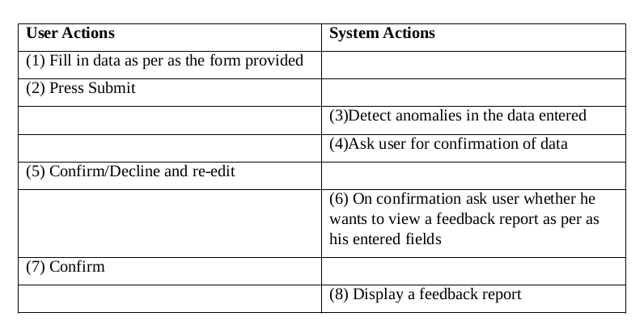
Chatbot Implementation and General Symptom Prediction
The software helps diagnosis ordinary ailments from symptoms with the help of an external API.

Functional Requirements
- Purpose: Diagnosis of ailments with the help of an external API
- Input: Comma separated symptoms in the form of textual entry.
- Processing: The feed thus generated is sent to an external API for processing.
- Output: The output obtained from the API is displayed

Stimulus Response

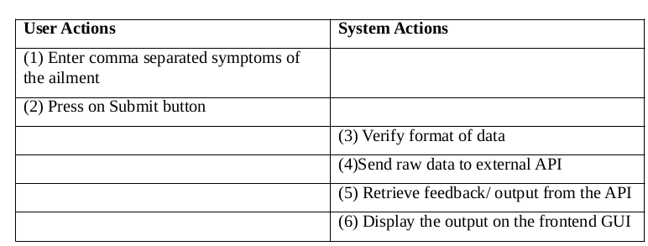

Contact and Make Appointments with Nearby Hospitals

This feature will capture the user’s device location and locate hospitals around a said kilometre radius. After location of the hospitals, the user is free to make appointments in any one of these hospitals. The user can avail the contact details and directly contact the aforementioned health centres .

Functional Requirements:
- Purpose: To facilitate users to make appointments to nearby hospitals in case of emergency conditions.
- Input: User click on locate hospitals, to generate list of nearby hospitals, then choose a hospital where the appointment should be made.
- Processing: The Google Geolocation API is used to track the user’s location and also facilitate making appointments to the hospitals.
- Output: A list of nearby hospitals is provided along with their contact details.

Stimulus Response

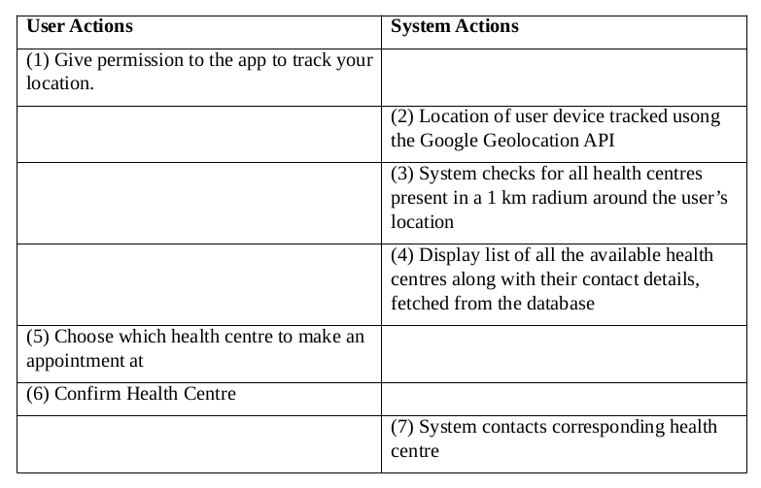

3.2.1.1 User characteristics
The HealthCare Application is using an external API, and Watson chatbot, and a rudimentary database to implement the required functionality, which has placed certain design constraints on the design of the application. The table below lists those design constraints.
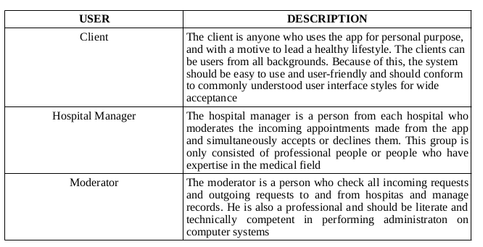
3.2.2.2 Assumption & Dependencies
The following table lists the assumptions made by the requirements that have been made in the Healthcare Application Software
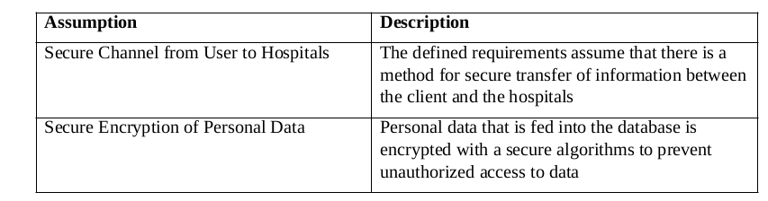
3.2.2.3 Domain Requirements
Domain requirements reflect the environment in which the system operates so, when we talk about an application domain we mean environments such as train operation, medical records, e-commerce etc.
Domain requirements are important because they often reflect fundamentals of the application domain. If these requirements are not satisfied, it may be impossible to make the system work satisfactorily. We would also require a domain name to establish the application.

3.2.2.4 User Requirements and Product Specific System Requirements
The following is a table of the requirements that the system SHALL meet. The list of the requirements was produced from the initial project documentation provided by the requirements experts.
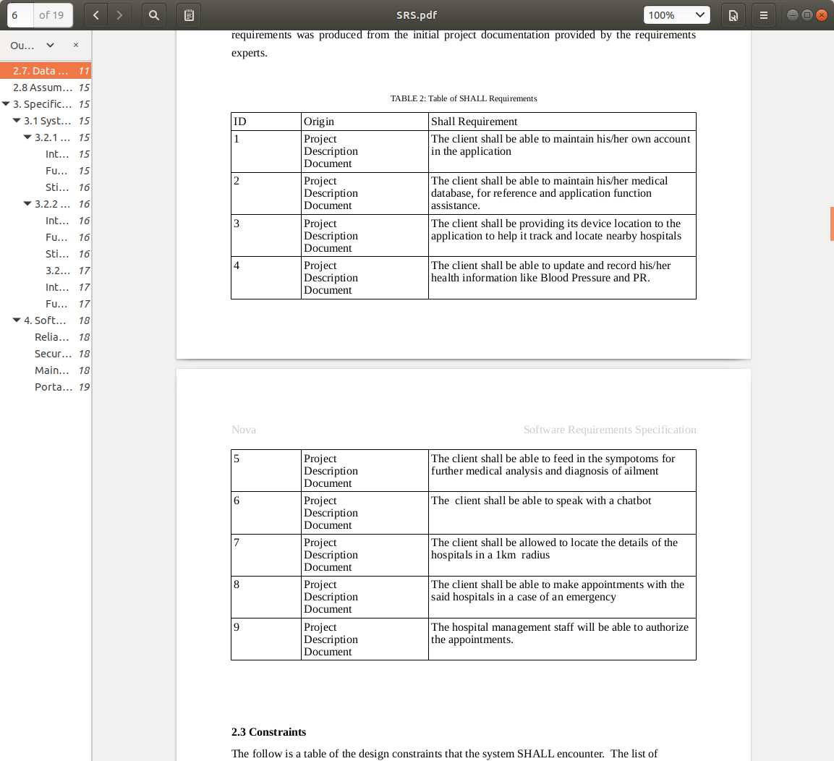

3.2.2 Non Functional Requirements
In systems engineering and requirements engineering, a non-functional requirement (NFR) is a requirement that specifies criteria that can be used to judge the operation of a system, rather than specific behaviors. They are contrasted with functional requirements that define specific behavior or functions. The plan for implementing functional requirements is detailed in the system design.

Reliability
Reliability in the HealthCare software will be ensured by thorough unit, milestone, and release testing. Comprehensive test scenarios and acceptance criteria will be established to reflect the necessary level reliability required of the HealthCare Application . The all delivered source code will be thoroughly tested using the established test scenarios until the acceptance criteria are satisfied by the HealthCare Application .

Security
The HealthCare Application software will utilize Pa secure key encryption strategy. Every medical record entered shall be securely encrypted.

Maintainability
Along with the well-formed programming enforced by Python, best practice development conventions will be enforced for the construction of the HealthCare Application . These will include adequate commenting within the source code that complies with and uses the automated Python documentation standard so that source code documentation will be able to be automatically generated. Consistent variable naming conventions will be used by all the programmers. Consistent spacing will be used in the source code by all the programmers. The design of the source code will use the principles of Object-Oriented Design and the source code will be programmed using Object-Oriented Programming. Object-Oriented Design and Object-Oriented programming will make the code easier to understand.

Portability
As mentioned above, the HealthCare Application will be written in Python and gain the portability providing by that language. It is safe to say that the implementation of the HealthCare Application will be able to be ported to other system platforms that accept Python applications with little to no changes required. It is not safe to say that the HealthCare Application will execute properly on the other system platforms with little or no change. Significant changes to the HealthCare Application may be required to ensure proper execution on other system platforms.

3.2.3. System Requirements
3.2.3.1 H/W Requirements(details about Application Specific Hardware)
This project has no specific hardware requirements. It only requires a personal computer with a decent processor and a network connection to work.

3.2.3.1 S/W Requirements(details about Application Specific Software)
The project requires a stable web browser, preferably the latest version of either Google Chrome or Mozilla Firefox, along with access to certain APIs which have already been looked into using API calls. This project also involves node modules (dependencies) which need to be installed in the computer before locally running the application.

4. Design of the Proposed System
4.1. Introduction
The purpose of the Software Design Specification is to describe the specific design of the Health Care Project. The specification includes an overview of the design along with software module decomposition

This document provides a detailed description of each software module’s design. For each module, a user interface design and class diagram design is given. As well, a process description is described for each module. It is in the process description that the details of what logic will need to be implemented are given.

4.2. High level Design

4.2.1 Software Model

Incremental Process Model
The project that I have chosen will be done using incremental process model. The given project has several complicated functionalities which can be broken down and grouped in accordance with the priorities of the user. For eg, the landing page and the other static pages can be grouped together, Watson chat bot in another, and finally the functionality to view and make appointments in another model. A partial implementation of the total system is constructed first, and then gradually increased functionalities are added.
The following are the planned increments for the project:
- 1st increment: Basic rudimentary functionality, with a functioning user interface, which are most important and also easy to be implemented.
  - User login/ signup
  - Entering, as well as maintaining their medical records
  - Viewing nearby health centers
- 2nd increment: Slightly complex functionalities
  - Making appointments to the hospitals
  - Viewing appointments that they have made
- 3rd increment: Functionalities to enhance user experience and interaction with the GUI
  - Implementation of a Watson Chatbot for customer interaction

The other models were deemed as unsuitable for the following reasons:
- The waterfall model was considered as unsuitable because it didn’t have flexible partitioning of the work in stages, and also, given the project had some complex requirements which haven’t been phased out properly
- There isn’t any adequate technical advice for risk analysis. Also, it requires a high administrative overhead
- Component Based Software Engineering model wasn’t suitable because of the unavailability of components
Prototyping model was deemed unsuitable for the purpose because the requirements as well as the resources of the project are clear.

4.2.2 Module Decomposition
The HealthCare application has been decomposed into the following modules:
- User Login/Signup and Data Authentication module: Allows the user to login/signup using his credentials
- Edit/Alter Medical database module: This allows the user to feed the database with details about his medical history.
- Make/View Appointments Module: This module allows to track all nearby health centres and allows the application to make appointments on the behalf of the user.
- Chatbot Module: This module involves a basic chatbot powered by IBM Watson.
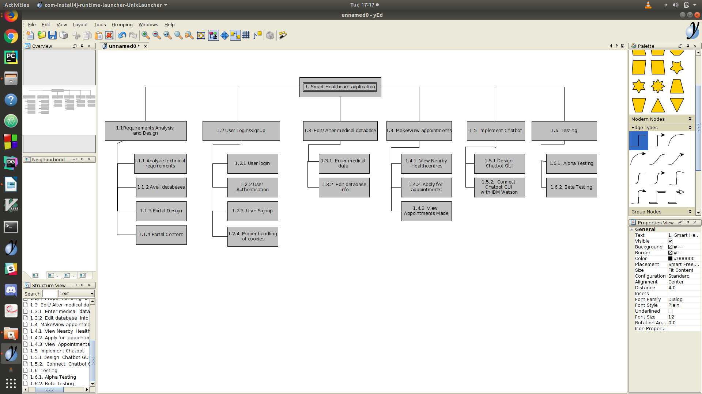

4.2.3 Activity Network

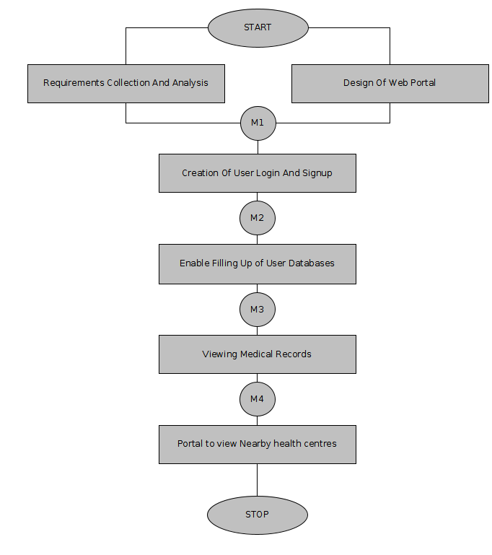

4.3. Detailed Design (ER Diagram/UML Diagram/ Mathematical Modeling)

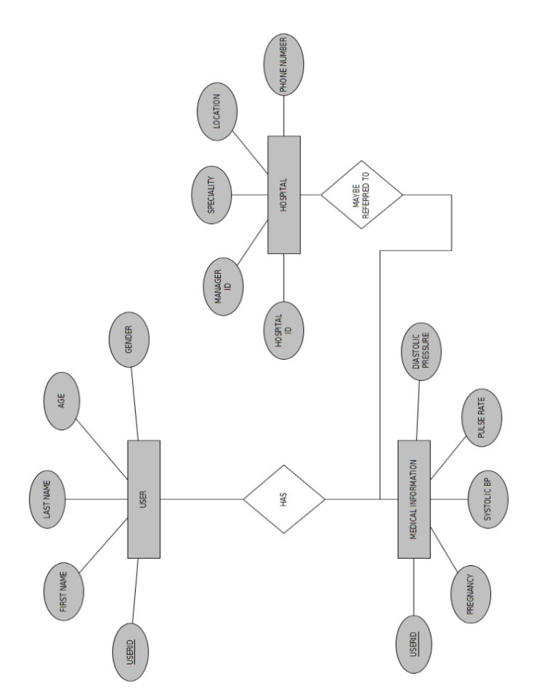
4.3.1. ER Diagram

4.3.2. Use-Case Diagram
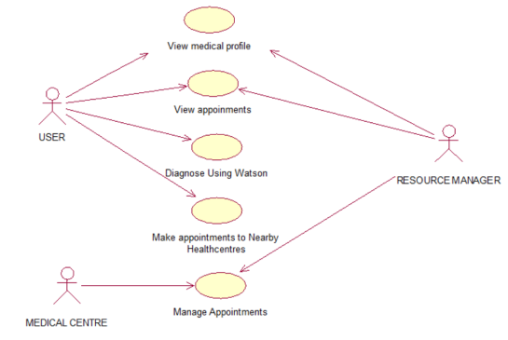

4.3.2. Sequence and Collaboration Diagrams

For Given Components In the Use case Diagram:
View Medical Profile
Sequence Diagram
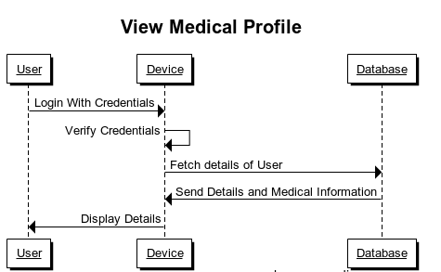

Collaboration Diagram
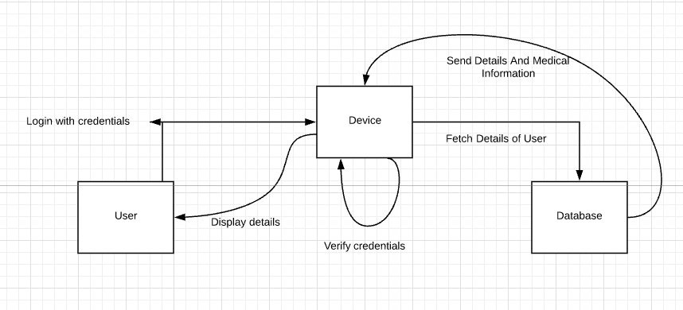

View Appointments
Sequence Diagrams
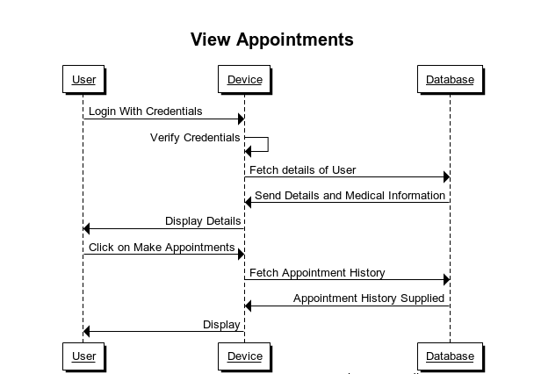

Collaboration Diagram
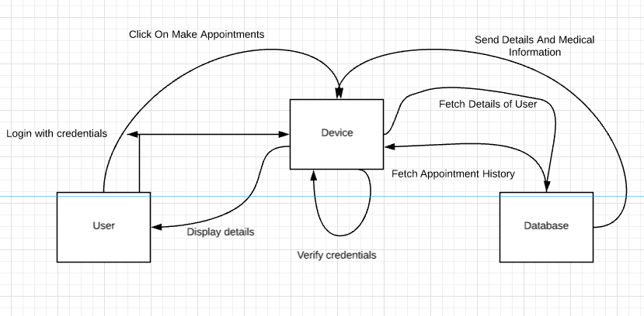

Diagnose Using Integrated API
Sequence Diagram
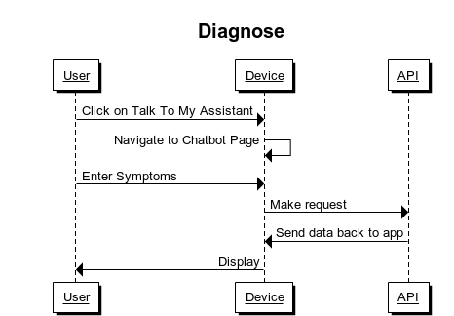

Collaboration Diagram
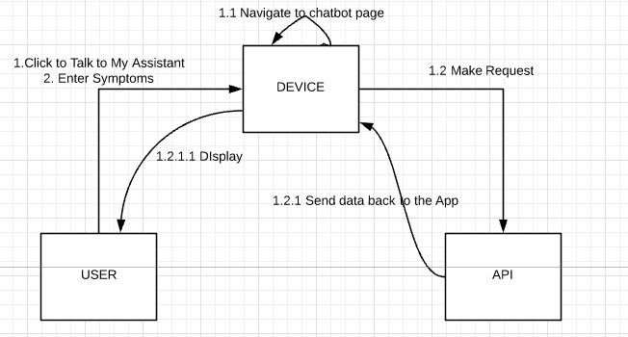

Make appointments to nearby Health Centers
Sequence Diagram
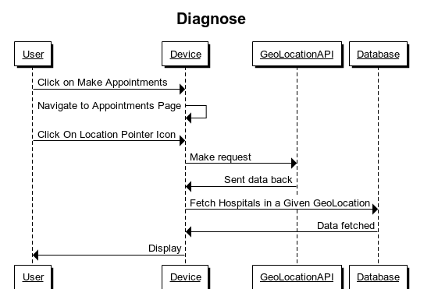

Collaboration Diagram
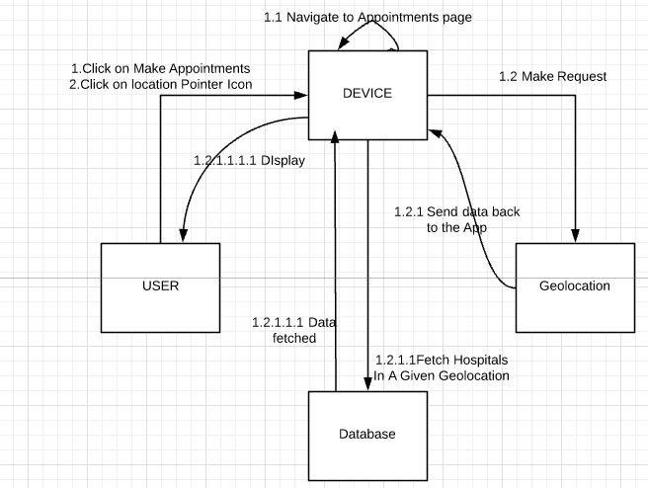

4.3.3. Detailed Descriptions and Activity Models For Major Operations
Login/ Signup:

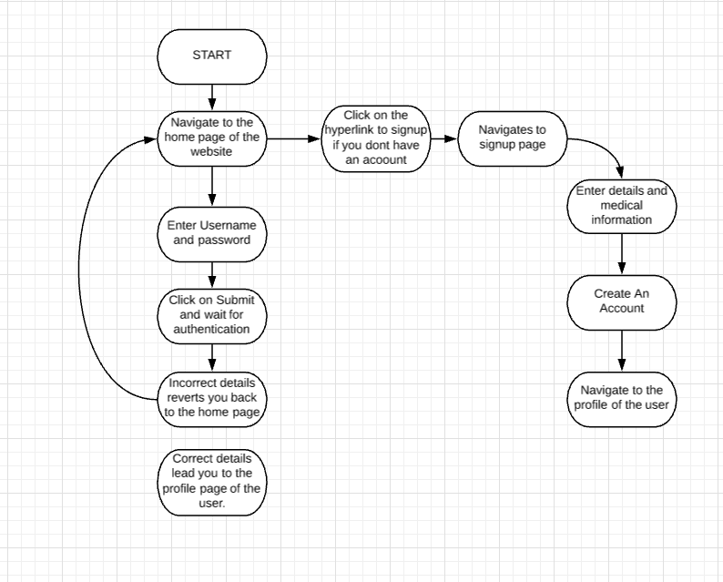

Edit/Alter Medical Database Entries:
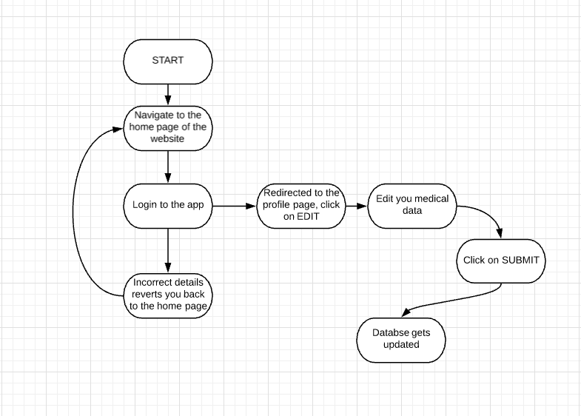

Disease diagnosis and Chatbot Communication:
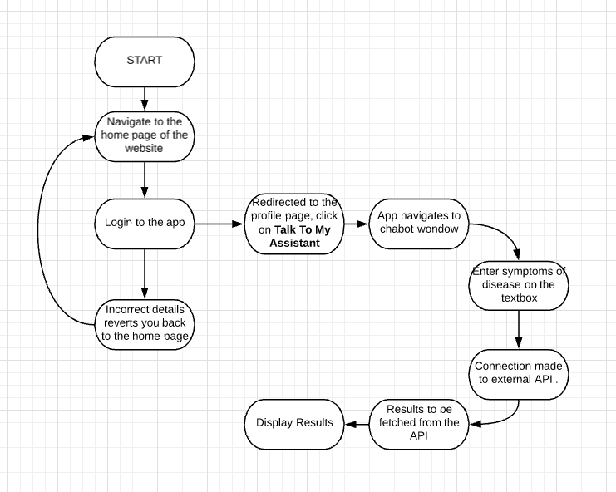

Make Appointments

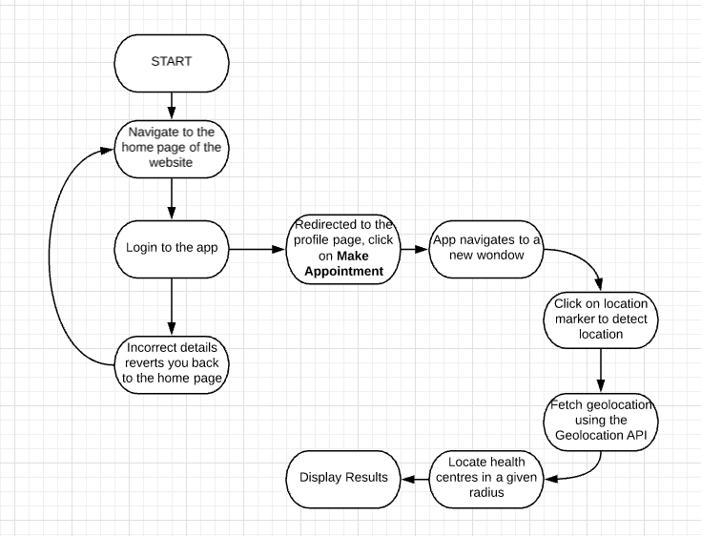

4.3.3. Class Diagram
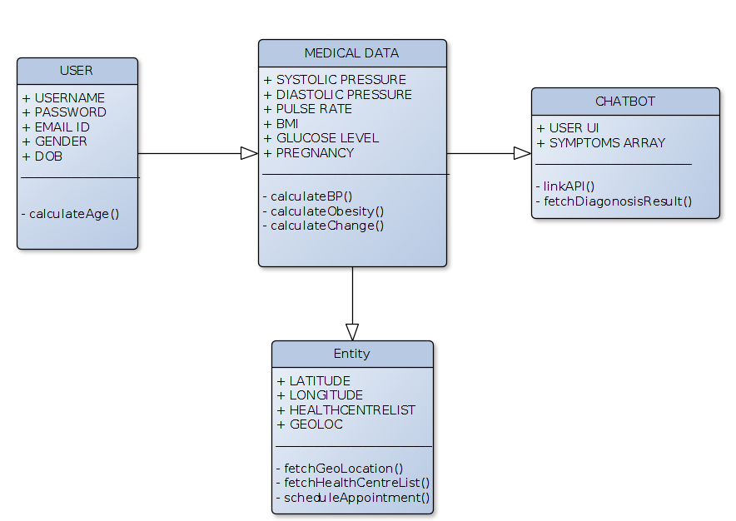
4.3.4. Data Flow Diagram
Level 0 DFD
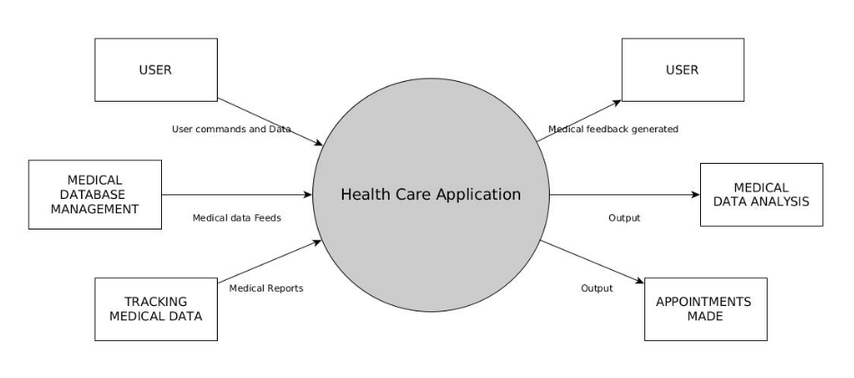
Level 1 DFD
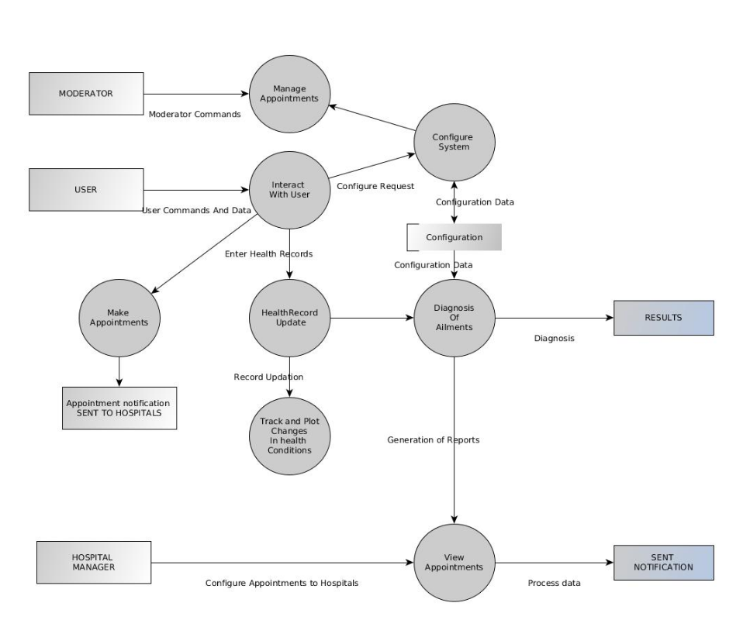

5. Implementation and Testing

Test Report
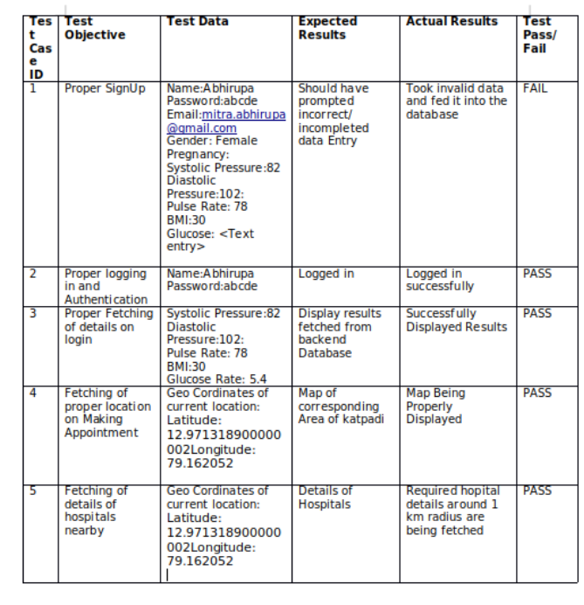

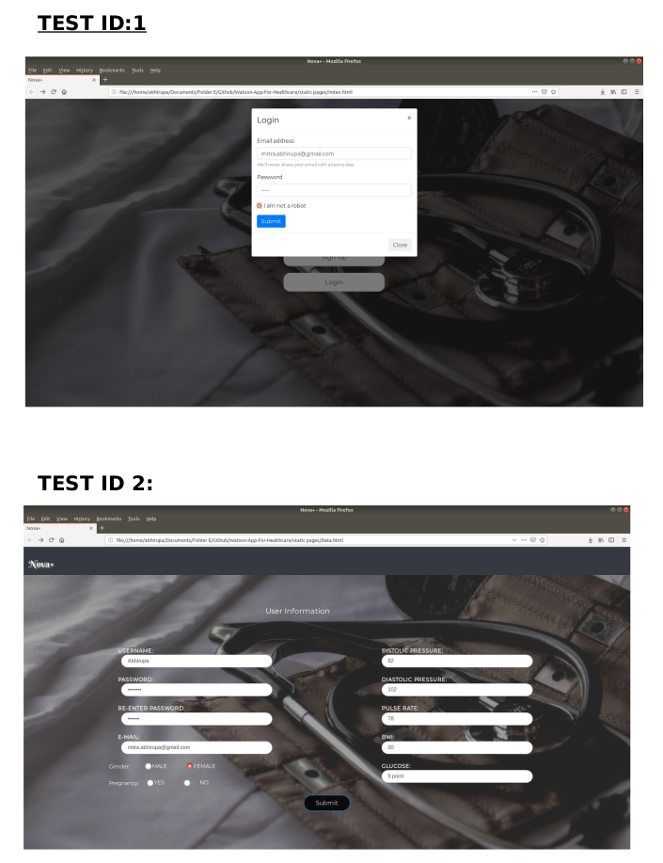

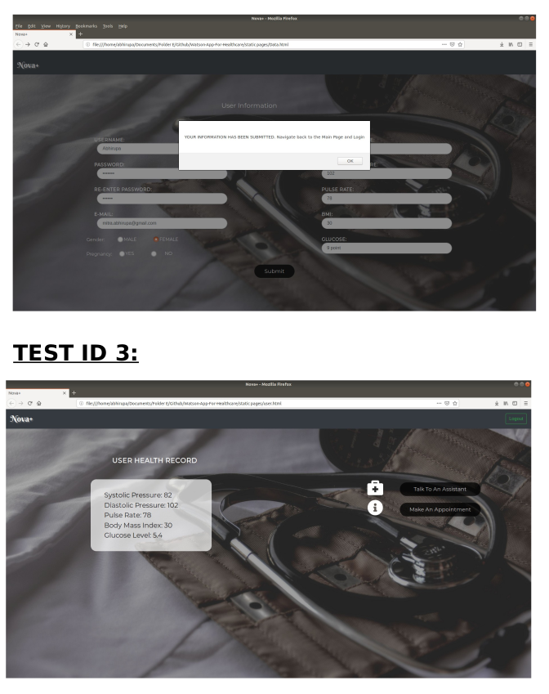

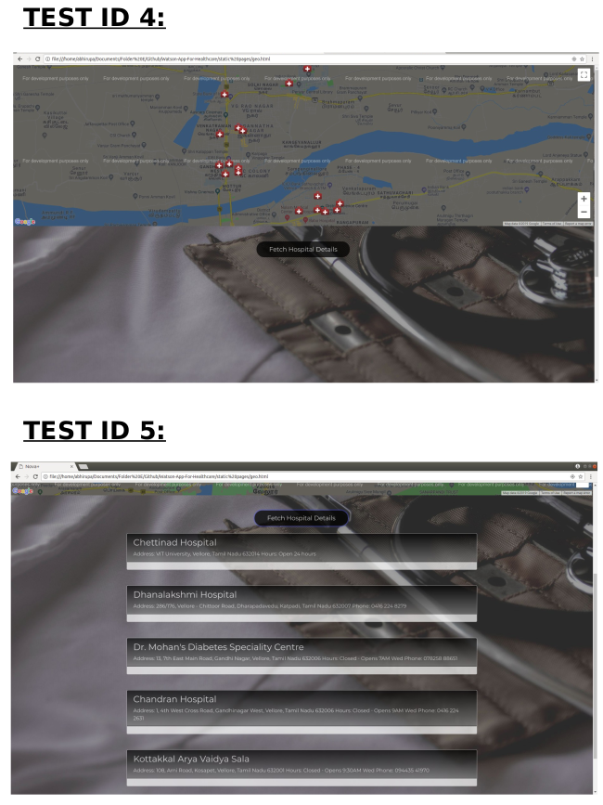

6. Conclusion, Limitations and Scope for future Work

Conclusion
The doctor and patient interaction plays the most vital role in healthcare delivery. In fact, it is a significant challenge while monitoring patients remotely. However, in this age of the advanced technology, it is not arduous to bridge that gap between a doctor and a patient.
Thence, several healthcare professionals are enthusiastic to develop a mobile application as it will help reach their patients anytime, anywhere and also improves the operating performance of their clinics. Moreover, people are also seeking quick and easy solutions for their health ailments.
Mobile applications for healthcare organizations help deliver services with quality care, improved workflow and increased patient interaction while minimizing complexity and cost to achieve the desired goals. The way the people adapt to mobile technology and looking for convenient approaches during illness has also increased the demand for mobile health apps.

Limitations
Unsurprisingly, security is a key consideration in the new regulatory regimes, which means it may not be acceptable to use insecure methods such as SMS texting or emailing to prompt data collection. Furthermore, the burden on the patient cannot be overlooked from an ethical perspective. How often is it acceptable to ask for data collection, such as through an app that uses the alarm clock feature of the smartphone?
Could illness or stress be exacerbated by a requirement to self-monitor and, if so, what degree of user involvement should be specified in the data collection process? It may be better to passively monitor rather than ask someone to self-monitor too often.
As with apps in general, users’ cognitive ability, prior experience of using computer systems and the internet and preferences for modes of communication will all have an impact on results. This fact suggests that a user survey or phone audit would ideally be conducted before commencing a design.
Some other real-world user issues have arisen in our pilot studies. Healthcare app users, like all phone users, do not always keep them turned on or charged up. For a research study this could be inconvenient or result in loss of data. A research instrument may also, in time, become a product and if an App is being used to monitor care these aspects of reliability will need to be assessed.

Scope
There is an increasing awareness in patients about medical health, and it’s giving rise to a new set of questions. Research is being done every day to reduce the minutest possible flaw in the health care system.
Web apps lack a dedicated, device-optimized user interface and thus cannot be precisely catered to fit a particular device’s form factor, input methods and screen size. Thus, web apps typically deliver an “abridged” user interface. Yet, there remains plenty of scope and opportunity for healthcare applications in different fields and domains, which are yet to be explored.

7. References
- https://console.bluemix.net/docs/services/conversation/getting-started.html#gettingstarted
- https://chatlio.com/docs/
- http://attunelive.com/7-key-focus-areas-mobile-healthcare-applications/
- https://docs.npmjs.com/cli/install

